1. **Analyse the mean , median, mode for below**

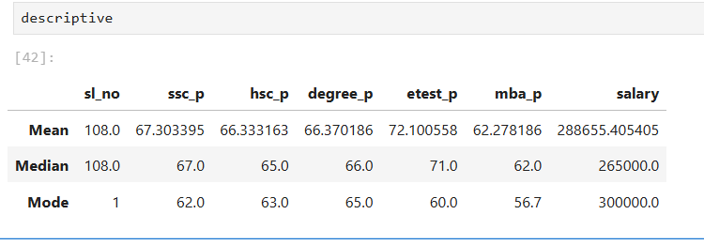

**Summary of Mean Median & Mode**:

**Mean:**

The average salary is ₹288,655, with an average SSC score of 67.30%, HSC score of 66.33%, degree score of 66.37%, entrance test score of 72.10%, and MBA score of 62.28%.

**Median:**

The median salary is ₹265,000, indicating that half the data falls below this amount. The median academic scores are generally close to their means, except for the entrance test score, which has a median of 71%.

**Mode:**

The mode (most frequent value) for salary is ₹300,000, suggesting a concentration of salaries around this value. Similarly, academic scores cluster around 62%-65%.

**2.Analyse the Percentile for below data**

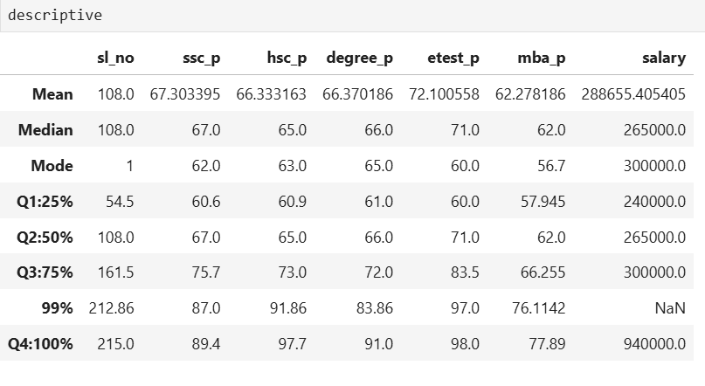

**Summary of Percentile:**

1. SSC_P (Secondary School Certificate Percentage)  
 - Q1:25%: 60.6%  
 - Q2:50% (Median): 67.0%  
 - Difference (Q2 - Q1): +6.4%  
 - Q3:75%: 75.7%  
 - Difference (Q3 - Q2): +8.7%  
 - 99%: 87.0%  
 - Difference (99% - Q3): +11.3%  
 - Q4:100%: 89.4%  
 - Difference (Q4 - 99%): +2.4%

Summary: SSC_P increases by 6.4% from Q1 to Q2, by 8.7% from Q2 to Q3, and by 11.3% from Q3 to the 99th percentile. There is a smaller rise of 2.4% from the 99th percentile to the maximum (Q4:100%).

# 2. HSC_P (Higher Secondary Certificate Percentage)

# - Q1:25%: 60.9% - Q2:50% (Median): 65.0% - Difference (Q2 - Q1): +4.1% - Q3:75%: 73.0% - Difference (Q3 - Q2): +8.0% - 99%: 91.86% - Difference (99% - Q3): +18.86% - Q4:100%: 97.7% - Difference (Q4 - 99%): +5.84%

# Summary: HSC_P increases by 5.0% from Q1 to Q2, by 8.0% from Q2 to Q3, and by a significant 18.86% from Q3 to the 99th percentile. The rise between the 99th percentile and Q4 is 5.84%.

# 3. Degree_P (Degree Percentage)

# - Q1:25%: 61.0% - Q2:50% (Median): 66.0% - Difference (Q2 - Q1): +5.0% - Q3:75%: 72.0% - Difference (Q3 - Q2): +6.0% - 99%: 83.86% - Difference (99% - Q3): +11.86% - Q4:100%: 91.0% - Difference (Q4 - 99%): +7.14%

# Summary: Degree_P shows consistent increases of 6.0% between Q1 to Q2 and Q2 to Q3, with a larger 11.86% jump between Q3 and the 99th percentile. The final rise between the 99th percentile and Q4 is 7.14%.

# 4. ETest_P (Entrance Test Percentage)

# - Q1:25%: 60.0% - Q2:50% (Median): 71.0% - Difference (Q2 - Q1): +11.0% - Q3:75%: 72.0% - Difference (Q3 - Q2): +1.0% - 99%: 97.0% - Difference (99% - Q3): +25.0% - Q4:100%: 98.0% - Difference (Q4 - 99%): +1.0%

# Summary: ETest_P shows an 11.0% increase from Q1 to Q2, a small 1.0% rise from Q2 to Q3, and a large jump of 25.0% from Q3 to the 99th percentile. The increase between the 99th percentile and Q4 is minimal at 1.0%.

# 5. MBA_P (MBA Percentage)

# - Q1:25%: 57.945% - Q2:50% (Median): 62.0% - Difference (Q2 - Q1): +4.055% - Q3:75%: 66.255% - Difference (Q3 - Q2): +4.255% - 99%: 76.1142% - Difference (99% - Q3): +9.8592% - Q4:100%: 77.89% - Difference (Q4 - 99%): +1.7758%

# Summary: MBA_P shows moderate increases of around 4.0% between Q1 to Q2 and Q2 to Q3, with a larger 9.86% rise from Q3 to the 99th percentile. The final increase from the 99th percentile to Q4 is 1.78%.

# 6. Salary

- Q1:25%: ₹240,000  
 - Q2:50% (Median): ₹265,000  
 - Difference (Q2 - Q1): +₹25,000  
 - Q3:75%: ₹300,000  
 - Difference (Q3 - Q2): +₹35,000  
 - 99%: After pre-processing data , will check the percentile of 99 for the salary column

- Q4:100%: ₹940,000  
 - Difference (Q4 - 99%): ₹0 (Same as 99%)

**Summary**: Salary shows moderate increases of ₹25,000 from Q1 to Q2, and ₹35,000 from Q2 to Q3, followed by a dramatic jump of ₹640,000 from Q3 to 100 percentile.

3.IQR lesser /greater outlier

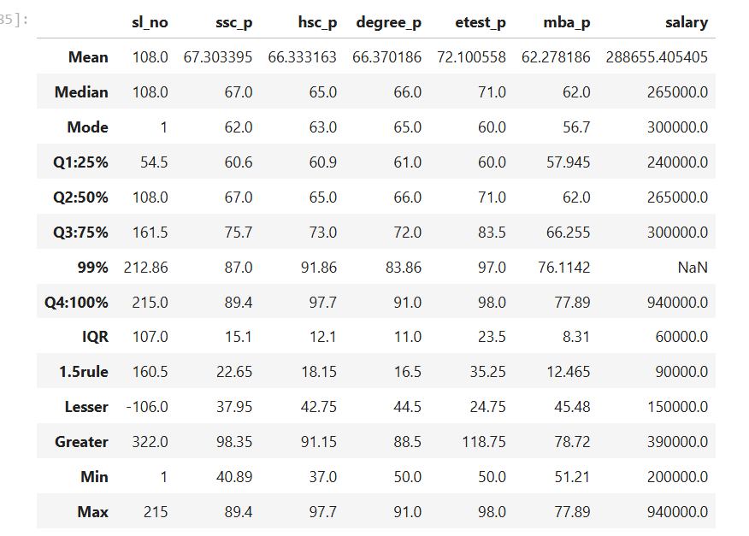

**Let's analyze the columns for outliers using the 1.5 IQR rule.**

1. ssc_p
   * Lesser: 37.95
   * Greater: 98.35
   * **Outliers**: None (Min = 40.89, Max = 89.4 within range)
2. hsc_p
   * Lesser: 42.75
   * Greater: 91.15
   * **Outliers**: Both lesser & greater outliers present slightly (Min = 37.0 ,Max= 97.7
3. degree_p
   * Lesser: 44.5
   * Greater: 88.5
   * **Outliers**: there is greater outlier (Min = 50.0, Max = 91.0 close to upper bound)
4. etest_p
   * Lesser: 24.75
   * Greater: 118.75
   * **Outliers**: None (Min = 50.0, Max = 98.0 within range)
5. mba_p
   * Lesser: 45.48
   * Greater: 78.72
   * **Outliers**: None (Min = 51.21, Max = 77.89 within range)
6. salary
   * Lesser: 150000
   * Greater: 390000
   * **Outliers**: Yes , there is greater outlier
     + Min = 200000 (Not an outlier, as it is above 150000)
     + Max = 940000 (Outlier, as it is greater than 390000!)

### Conclusion:

* The only clear outlier is in the salary column: 940000.
* Other columns do not have extreme outliers based on the 1.5 IQR rule.

IQR:Ref

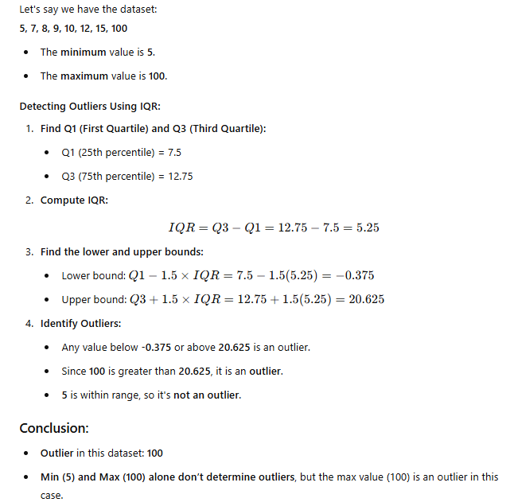

# 4.Skewness & Kurtosis

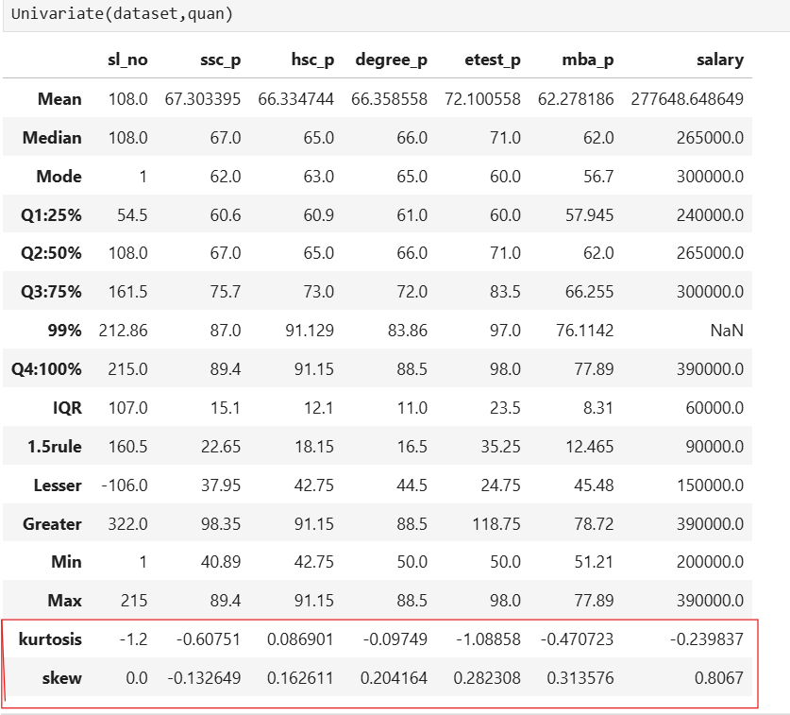

Summary of Skewness and Kurtosis for Each Column:

1. ssc_p
   * Skewness: -0.13 (slight left skew).
   * Kurtosis: -0.61 (light tails).
   * Distribution: Nearly symmetric (mean ≈ median), with a minor left skew and flat distribution.
2. hsc_p
   * Skewness: 0.16 (slight right skew).
   * Kurtosis: 0.09 (close to normal).
   * Distribution: Mild right skew, near-normal tails. Mean slightly higher than median.
3. degree_p
   * Skewness: 0.20 (right skew).
   * Kurtosis: -0.10 (slightly light tails).
   * Distribution: Right-skewed with a flat profile. Mean and median are nearly equal, suggesting limited skew impact.
4. etest_p
   * Skewness: 0.28 (moderate right skew).
   * Kurtosis: -1.09 (very light tails).
   * Distribution: Right-skewed with a flatter peak and fewer outliers (mean > median).
5. mba_p
   * Skewness: 0.31 (right skew).
   * Kurtosis: -0.47 (light tails).
   * Distribution: Right-skewed with a flat profile. Mean slightly higher than median.
6. salary
   * Skewness: 0.81 (significant right skew).
   * Kurtosis: -0.24 (slightly light tails).
   * Distribution: Strong right skew (mean > median), typical for salary data with high earners. Light tails indicate fewer extreme values than a normal distribution.

Key Observations:

* Salary has the most pronounced skewness, indicating higher earnings for a minority.
* Etest_p has the flattest distribution (lowest kurtosis).
* Most variables are near-symmetric (skewness close to 0) except salary.
* All columns exhibit platykurtic (light-tailed) distributions.